


Software Requirements Specification
for
Expense Tracker
Version 1.0

Prepared by

Akshay Rajeev | 140953130 | akshayrajeev1996@gmail.com
Akriti Nagar | 1409530 | akriti.nagar@gmail.com

Instructor: | Mr.Arjun C.V, Ms. Pooja S, Mr. Rajesh A
Course: | Computer and Communication
Lab Section: | A1
Date: | 30/3/2017
Contents
Revisions iii
1 Introduction 1
1.1 Document Purpose 1
1.2 Product Scope 1
1.3 Intended Audience and Document Overview 1
1.4 Definitions, Acronyms and Abbreviations 1
1.5 Document Conventions 1
1.6 References and Acknowledgments 1-2
2 Overall Description 3
2.1 Product Perspective 3
2.2 Product Functionality 3
2.3 Users and Characteristics 3
2.4 Operating Environment 3
2.5 Design and Implementation Constraints 4
2.6 User Documentation 4
2.7 Assumptions and Dependencies 4
3 Specific Requirements 5
3.1 External Interface Requirements 5
3.2 Functional Requirements 5
3.3 Behaviour Requirements 6
4 Other Non-functional Requirements 7
4.1 Performance Requirements 7
4.2 Safety and Security Requirements 7
4.3 Software Quality Attributes 7
5 Sequence Diagram 8
6 Activity Diagram 9

Revisions
Version | Primary Author(s) | Description of Version | Date Completed
Version 1.0 | Akshay Rajeev  Akriti Nagar | Original draft of Expense Tracker. An easy to use application for keeping track of a person’s financial flow. | NA

Introduction
The expense tracker is an application being developed for android users to keep an accounted documentation of expenses incurred through day to day life

Document Purpose
To give a small abstract on why such an application is required lets examine a daily routine that is obvious to everyone yet is not voiced due to the trivial nature of the subject. Its commonly found that as and when money is withdrawn it seems to fly from your wallet/purse. When it comes to looking back and accounting for where it went more often than liked the purpose is lost. To overcome this highly distracting feature, the need for an accounted description of where and when money was spent becomes absolutely necessary.
This application is being developed with this in mind and to bring about a stable flow of money across all platforms.

Product Scope
The application being developed on Android studio is an android application that is open to all users that have accountable cash in any form be it pocket money for a kid to a businessman looking to take care of daily expenses seperately. Its also being equipped with an efficient notification system for daily reminders to update the day’s expenses and also for low and deficient balance.

Intended Audience and Document Overview
This document is intended to give its readers, namely the professors evaluating this applications and any user willing to try understand the scope of this project or is interested in using the application post development.

Definitions, Acronyms and Abbreviations
The following documentation is done in simple english and doesn’t require a lot of interpretations. If any please refer to a dictionary as all terms used are off the english dictionary with very less additional information for interpretation,

Document Conventions
This document follows a uniform font size of Arial 11 with easy to follow English and is documented according to the IEEE standard set for any Software Requirement Specifications(SRS).

References and Acknowledgments
This application is purely constructed on the ideas put forward by the primary authors of this document. Additionally the authors would like to thank the following mentioned names for giving the opportunity to work on this applications and for any valuable inputs that we have recieved and yet to recieve.

[1.] Mr. Arjun C.V, Professor,ICT Department, MIT Manipal
[2.] Ms. Pooja S, Professor, ICT Department, MIT Manipal
[3.] Mr. Rajesh A, Professor, ICT Department, MIT Manipal
[4.] All lab assistants for maintaining the equipment required to complete this application.

Overall Description

Product Perspective
Being outstation students of a college its not often that one person can’t term themselves as “broke” or having a lack of cash and left wondering where it all went. Adding to that is the fast paced life that one is required to adapt when left on their own to figure out how the world works. To make this transition easier the authors of this document felt its necessary to keep an easy to use application that looks at all the small and simple things about money management that is realised from personal experiences. Following on this concept this product requires a constant updation of an expense as and when it occurs with simple and easy selections and allow for the application to make calculations on its own. Another major feature this application is designed to track is the concept of borrowing/lending money to friends and forgetting about it. This also leads to unaccounted money that if unfortunately is neglected by the other party brings up another discrepancy in the finances. All new transactions automatically update all involved datasets that are concerned with the new update.
This product is a standalone collaboration done by the authors of this document and no external influences.

Product Functionality
The functionalities deployed in this application are
- Login features to secure and filter out unwanted access into personal expenses
- Registration features for new users
- New expenses updation for any new transaction committed including deposits and withdrawal
- Automatic calculation of all corresponding balances that are affected when a transaction is committed.
- Special feature for adding names and money owed by/to the given entity.
- Calculation of digitized money and in-hand cash

Users and Characteristics
This application is designed to be easy to use and is appropriate for users of all ages as long as the user has a financial income from any source(self or parents). The application doesnt differentiate between users by user specifics due to openness and generality of the need for such an application.

Operating Environment
The application is open to all android users that have an operating system of Android Version 4.4(KitKat) and up. It also requires an environment with legitimate transactions and a universal unit across all balances. Any device that is able to support the give Android version will allow a smooth working of this application.

Design and Implementation Constraints
Constraints for a smooth working include
- Lending/Borrowing money has to be updated according to the platform used for the given cash transaction
- If the bank balance has reached 0 there requires to be a precise account of in hand cash to stop descrepancies.
- A consistent and understandable error handling condition when the given expense is more than the total cash available to that user.
- Conversion rates of different currencies have to be considered appropriately.
- Trivial amounts(eg. Rickshaw expenses) have to be updated as and when it occurs.

User Documentation
The settings menu is designed to offer a help option which will give a step by step instruction for use of this application and tackling error conditions if any.

Assumptions and Dependencies
It is essential that the user supplies timely and valid information into the application for a smooth and efficient running and also to not bring about unnecessary complications which defeats the purpose of using such an application.

Specific Requirements

External Interface Requirements

User Interfaces
Multiple UI for different functionalities are used and they are as follows
- Login
- Registration for a new user
- Options menu that includes deposit, withdrawal, expenses, lending/borrowing.
- Pop-up menus for updating balance.
- Drop-down menus for banks and payment by cash or card
- Graphic icons for different categories such as food, entertainment, household, transport,etc.

Hardware Interfaces

A mobile device that is Android compatible with version above Kitkat (4.4) and a sensor touch screen for efficient working while using the application.

Software Interfaces
Android is the mobile operating system necessary for the application to run. It must have a minimum version of 4.4 (kitkat) and is based on the java framework.
Different packages include android.support.v7, android.graphics for graphical icons, android.view that consists of menus and views, android.widget for other functions like button, toast, text, etc.

Functional Requirements
< Functional requirements capture the intended behavior of the system. This behavior may be expressed as services, tasks or functions the system is required to perform. This section is the direct continuation of section 2.2 where you have specified the general functional requirements. Here, you should list in detail the different product functions with specific explanations regarding every function.

TO DO: Brake the functional requirements to several functional areas and divide this section into subsections accordingly. Provide a detailed list of all product operations related to these functional areas.

Behaviour Requirements

Use Case View
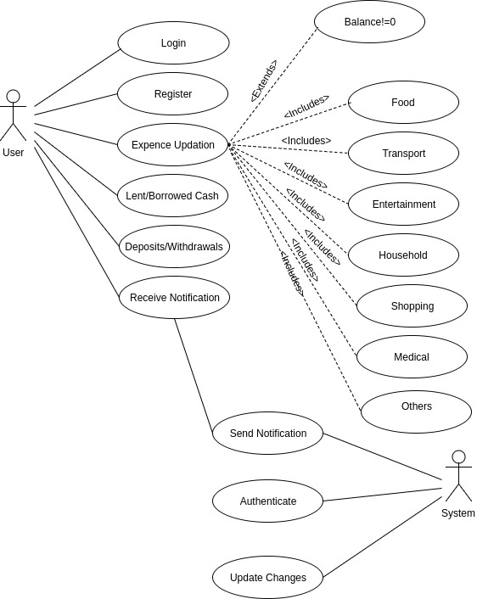

Other Non-functional Requirements

Performance Requirements
For optimum performance and minimal error conditions its expected that
- The user enters correct or an almost exact approximation of the amount that he/she has spent to avoid later complications.
- The user enters all available options that correspond to the function for optimal and a balanced work around the entire platform.
- The user does not enter values that do not compute like misplaced characters.
- When net worth is below 0, the user has to make sure any new transaction can be traced appropriately.

Safety and Security Requirements
The application is expected to deploy the given safety methods
- A secure and encrypted dataset for login credentials.
- No integration or permissions for other applications to acces the data available.
- Money updation has to be highly channeled to use only the fields that are involved when that transaction occurs.

Software Quality Attributes
4.3.1 Reusability
The application when wiped can be used to operate in the same manner with memory of values linked to the account/login details provided.
4.3.2 Verifiable
The application provides all outputs and maintains a record of inputs to cross verify the amounts given at an point of time
4.3.3 Maintenability
The application requires low amount of changes and doesnt require a thorough inspection to find errors or discrepancies. It would be self handling.

\Other Requirements
Sequence Diagram

Appendix A – Data Dictionary

Activity Diagram

